**To:** Jie Yang  
**From:** Team 5, EE-286 Section 1Mason Gerace, Felecia Hildebran, Joshua Pollock, Taylor Yee  
**Date:**  November 20, 2018 **RE:** Project 3 - Update Memo 2

**Assignment:**

The team will submit a memo detailing the progress made on this project to date. This will include a Gantt chart updated to reflect any changes in the scheduling. In particular, the Gantt chart must breakdown the tasks involved in the project construction (at least two or three individual tasks) and coding phases of the project. The original Gantt chart will be presented along the revised chart with detailed annotations of the changes. Don’t forget to include the task accountability info (who was assigned to the task and who actually did the task) preferably in the form of a WBS. This will be due November 20, 2018 at 11:59 pm.

**Introduction:**

The team is submitting a memo to update the TAs and Professor Yang on the progress made on the project to date. This will include a revised Gantt chart to give more details on the coding and project construction aspects, as well as revised scheduling dates. Additionally, an updated WBS chart will be presented to show changes in responsibilities for tasks. Finally, an overall update on the construction and functionality of the project will be presented.

**Updates to Gantt Chart:**

* Added design and print 3D wheels to the build and test section and added its ideal timeline to start on November 12th and end by November 16th
* Added mount wheels to breadboard to the build and test section and added its ideal timeline to start on November 16th and end by November 20th
* Added ensure device moves properly to the build and test section and added its ideal timeline to start on November 20th and end by November 23rd

**Gantt:**

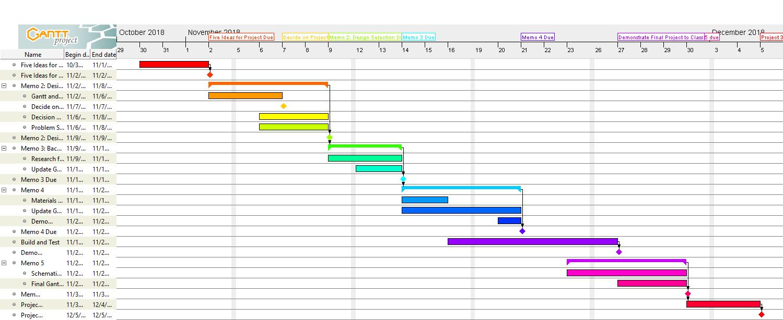

**Figure 1: Original Gantt Chart**

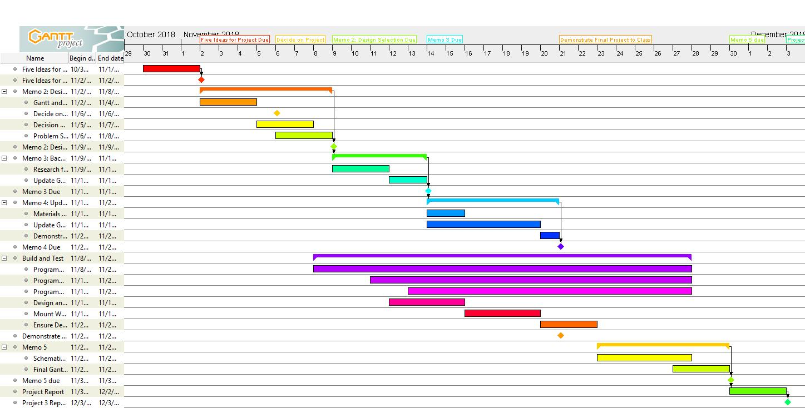

**Figure 2: Updated Gantt Chart**

**Updates to WBS:**

* Research Memo now completed
* Update Memo 1 now completed
* Update Memo 2 currently in progress
* Coding and building phases are in progress
* Team members assigned to corresponding assignments

**WBS:**

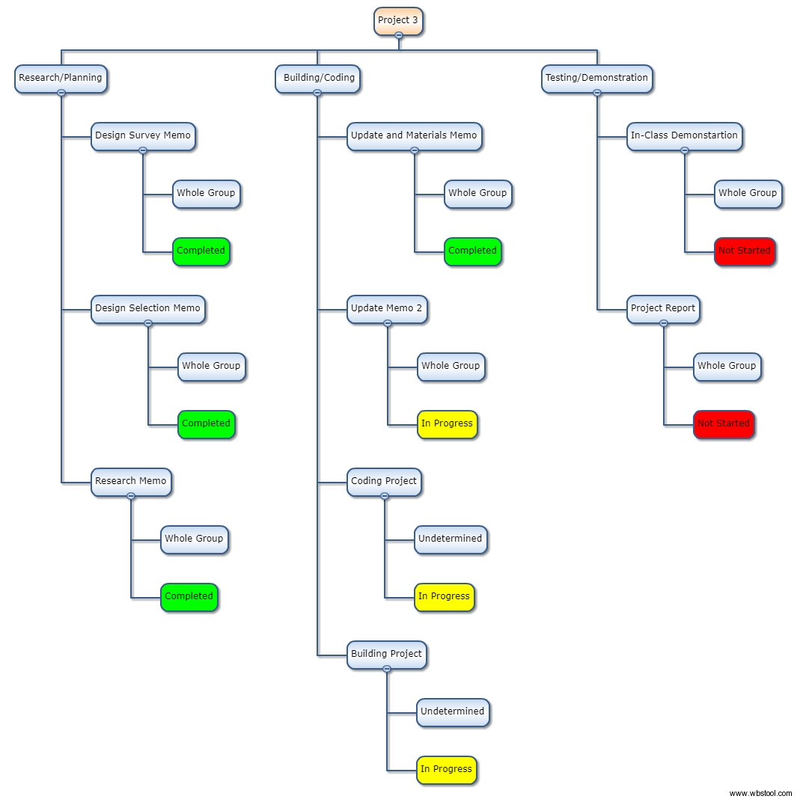

**Figure 2: Updated WBS chart**

**Conclusion:**

In this memo, our team presented updated versions of our Gantt and WBS charts, which in turn reflect the progress we have made on our project. Moving forward, our next steps will be to continue programming the rover and troubleshoot the functionality  
of our wheels in order to ensure that it meets the requirements outlined in  
previous memos. Looking at the Gantt and WBS charts as forms of tracking progress, we should be able to complete the project before the deadline.

**Attachments**: none